Screenshot of AAA server

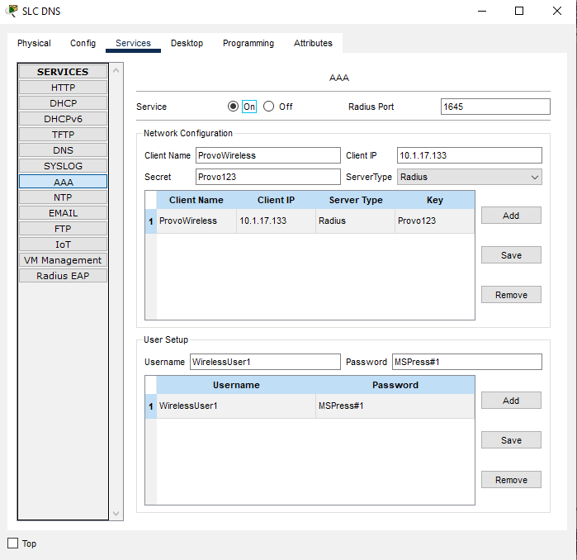

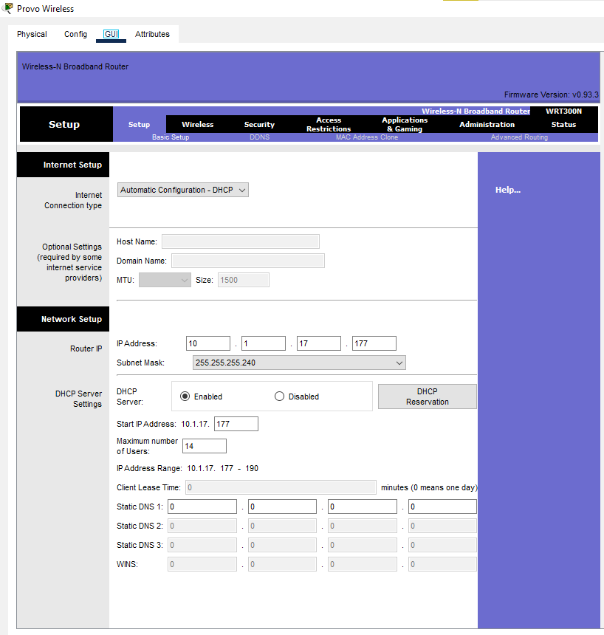
Screenshot of Setup page from 1 Wireless Router showing Network Setup

Wireless Security showing RADIUS Server configuration

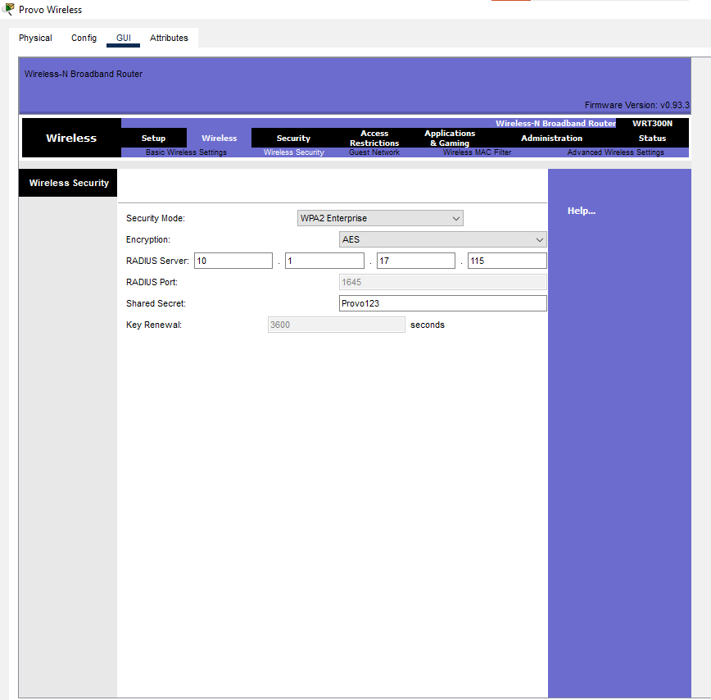

Screenshot of topology with at least two connected laptops

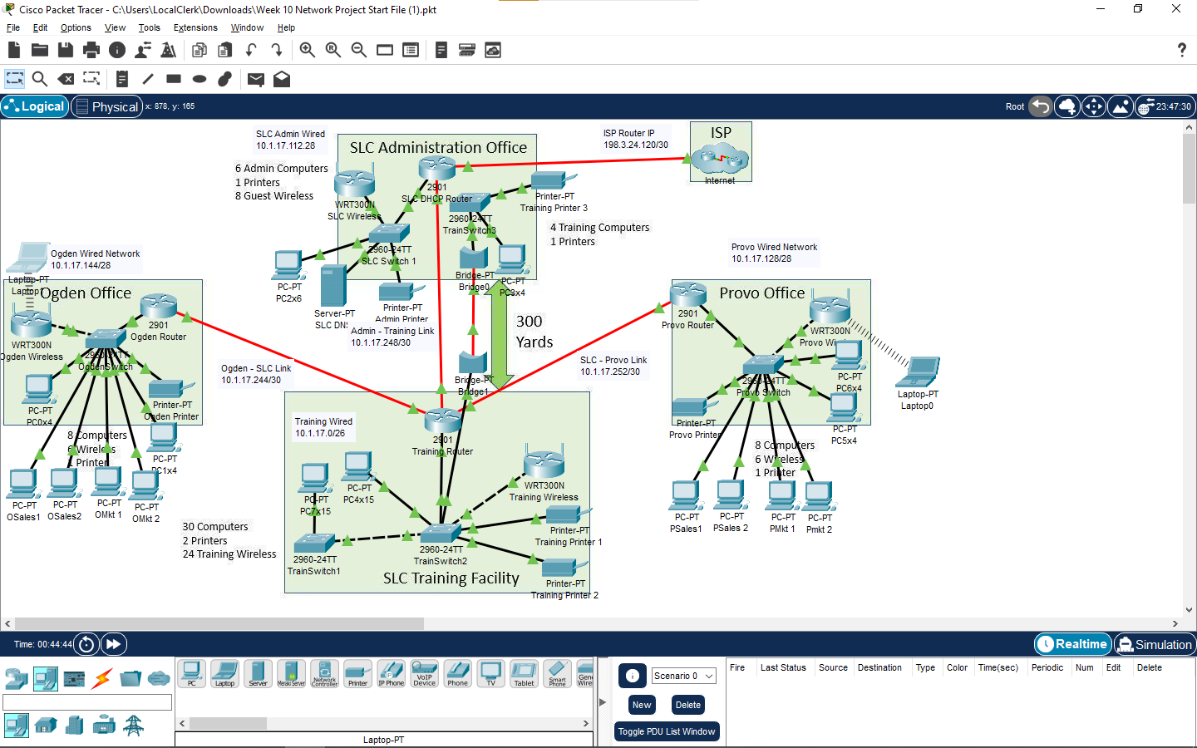

Screenshot of laptop accessing www.cisco.com

